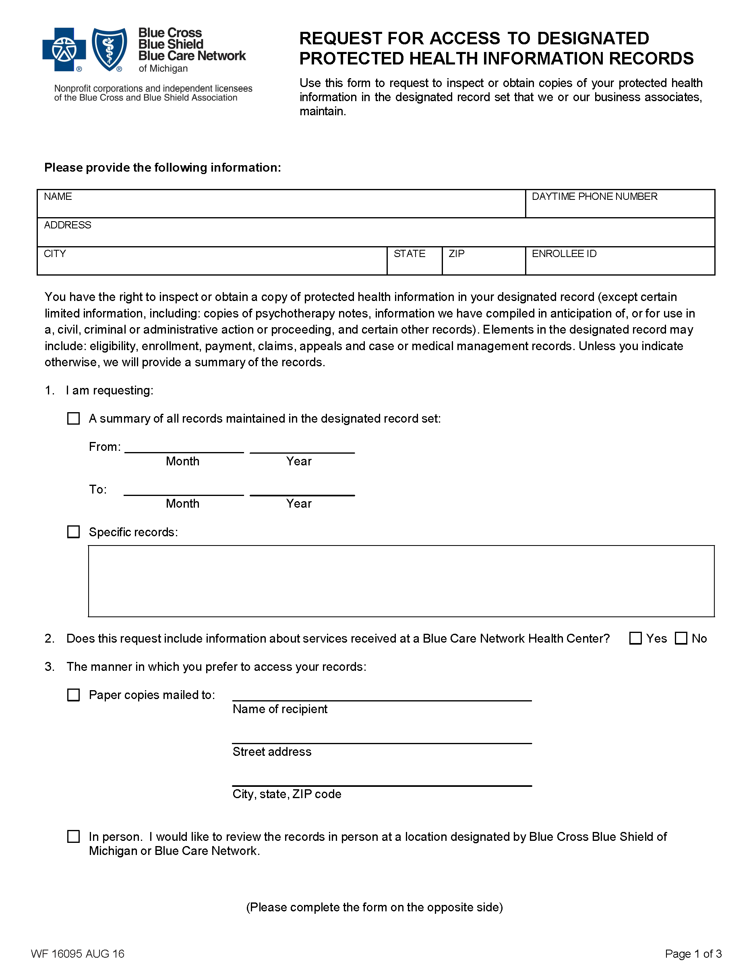
Secret Location Under Office Building
Gotham
NJ

Cust. Svs. No. from back of BCBS Card:
Batman

FROM 01/01/1979 TO PRESENT: Any and all MEDICAL RECORDS, including but not limited to patient history form(s), reports, etc. pertaining to Batman SSN: xxx-xx-5555, DOB: 01/01/1979.
X
Order No. 01-29018-002

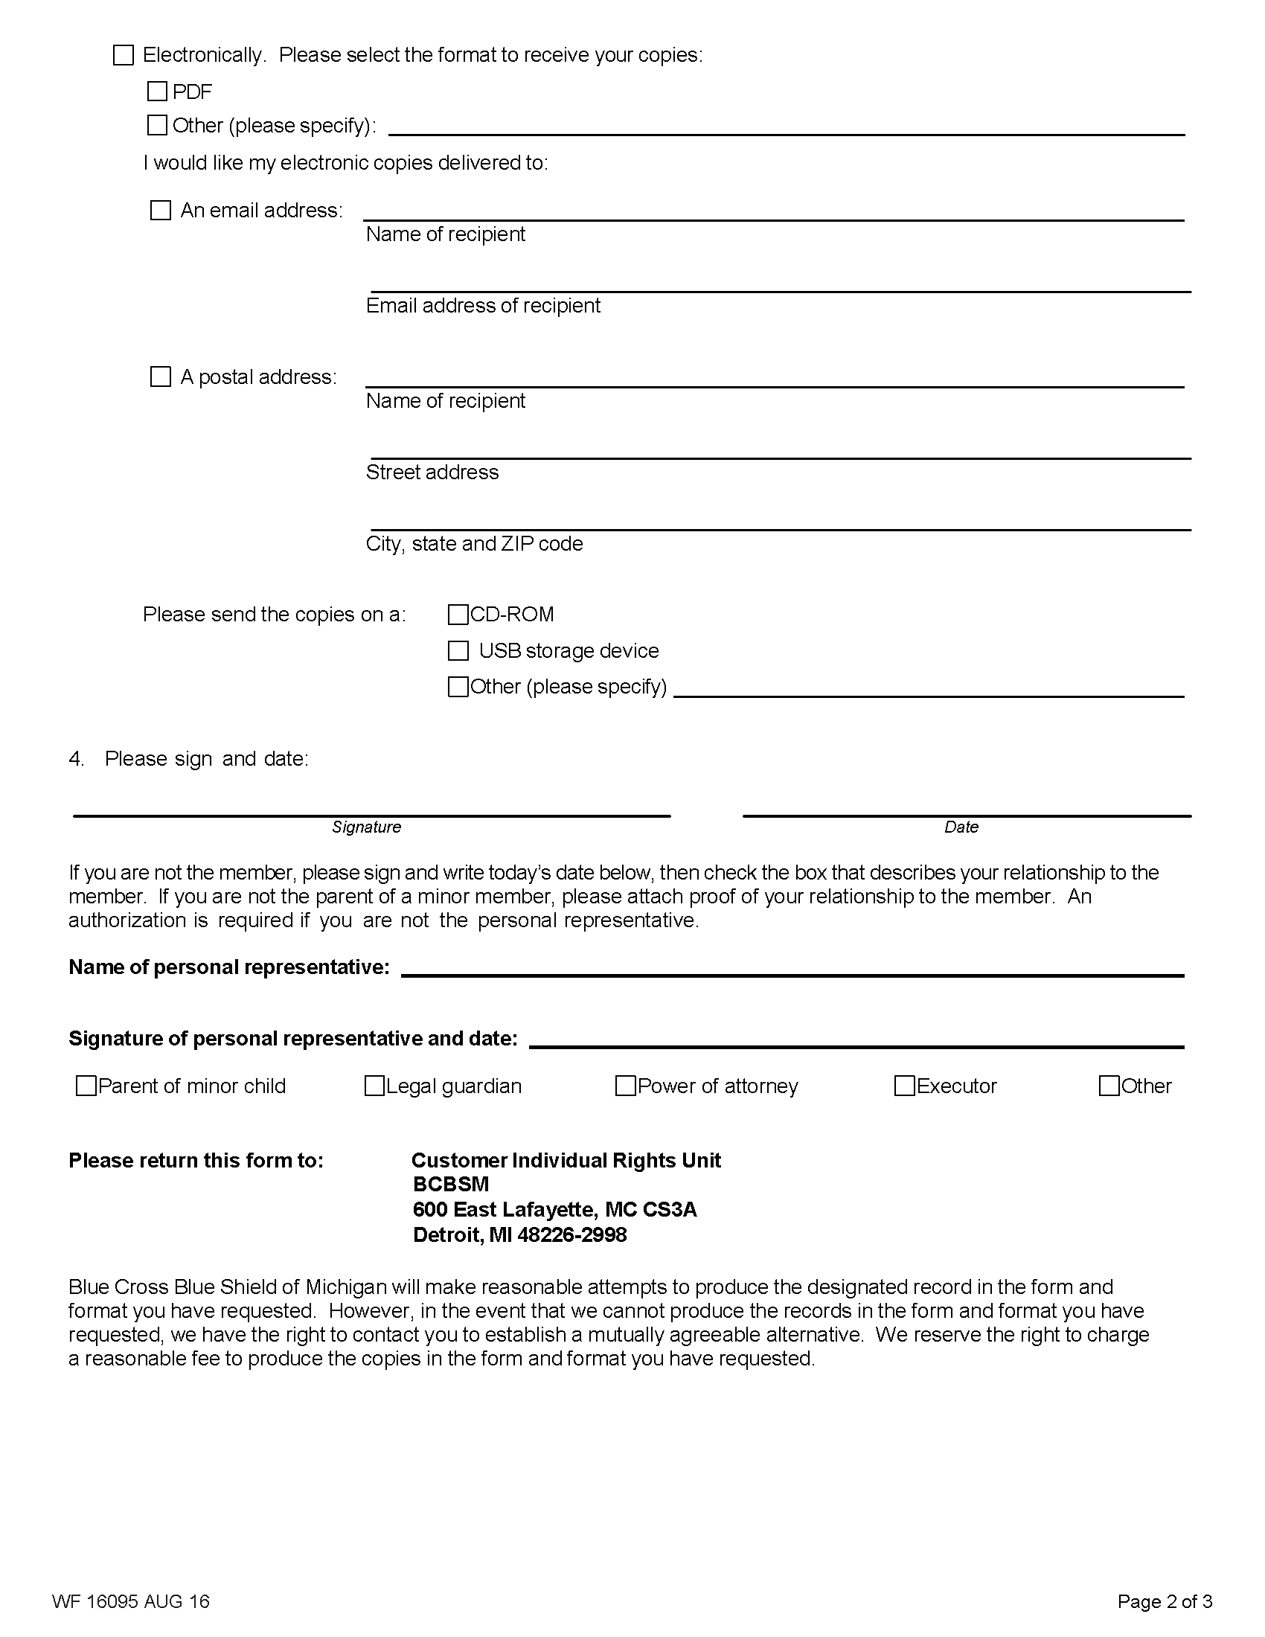
X
Axiom Requisition Copy Service

2869 Jolly Road

Okemos, MI 48864
X
X
X
Axiom Requisition Copy Service
records@axiomcopy.com
Order No. 01-29018-002
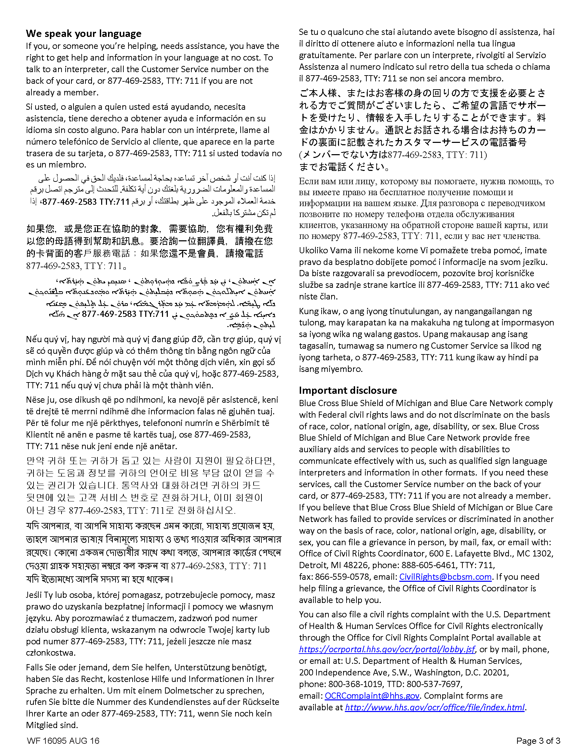
Order No. 01-29018-002
The End of the Legal Matter

